**AWS CLI**

* Let’s try to create aws vpc with 6 subnets using AWS CLI 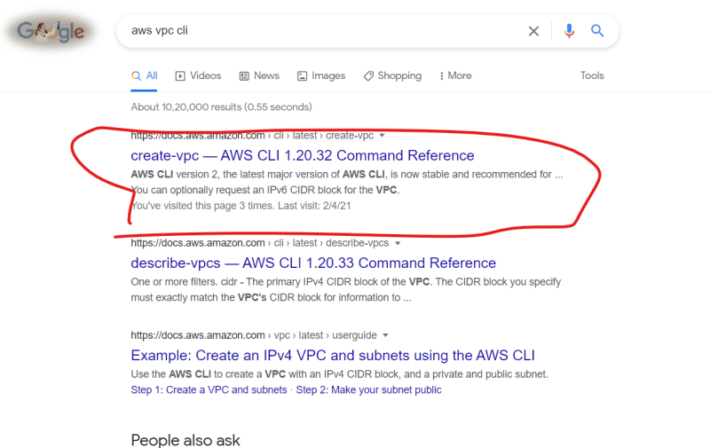

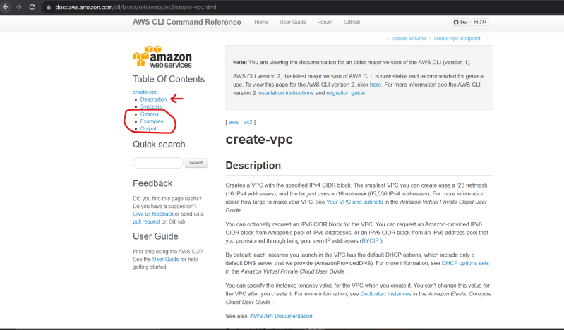

AWS CLI will be in the format

aws <service> <sub-service> <command> [args]

* Generally, for the commands to get the items we will have describe prefix
* We have created a vpc with one subnet try to add 5 more



* Create an internet gateway and attach it to vpc

aws ec2 create-subnet --cidr-block '192.168.0.0/24' --tag-specifications "ResourceType=subnet,Tags=[{Key=Name,Value=web1}]" --vpc-id "vpc-04acb61dbc8b814c7" --availability-zone "us-west-2a" # "SubnetId": "subnet-0b8b36e0ae7a2b040"

aws ec2 create-subnet --cidr-block '192.168.1.0/24' --tag-specifications "ResourceType=subnet,Tags=[{Key=Name,Value=web2}]" --vpc-id "vpc-04acb61dbc8b814c7" --availability-zone "us-west-2b" #"SubnetId": "subnet-0157da4c7a92eb1d9"

aws ec2 create-subnet --cidr-block '192.168.2.0/24' --tag-specifications "ResourceType=subnet,Tags=[{Key=Name,Value=app1}]" --vpc-id "vpc-04acb61dbc8b814c7" --availability-zone "us-west-2a" # "SubnetId": "subnet-063a24cd079bc5ff6"

aws ec2 create-subnet --cidr-block '192.168.3.0/24' --tag-specifications "ResourceType=subnet,Tags=[{Key=Name,Value=app2}]" --vpc-id "vpc-04acb61dbc8b814c7" --availability-zone "us-west-2b" # "SubnetId": "subnet-0f50fceb36b1c4833"

aws ec2 create-subnet --cidr-block '192.168.4.0/24' --tag-specifications "ResourceType=subnet,Tags=[{Key=Name,Value=db1}]" --vpc-id "vpc-04acb61dbc8b814c7" --availability-zone "us-west-2a" # "SubnetId": "subnet-014b090887965363c"

aws ec2 create-subnet --cidr-block '192.168.5.0/24' --tag-specifications "ResourceType=subnet,Tags=[{Key=Name,Value=db2}]" --vpc-id "vpc-04acb61dbc8b814c7" --availability-zone "us-west-2b" # "SubnetId": "subnet-0ecd212a19a0427ae"

aws ec2 create-internet-gateway --tag-specifications "ResourceType=internet-gateway,Tags=[{Key=Name,Value=ntierigw}]" # "InternetGatewayId": "igw-09baaac90b9e1aaf6"

aws ec2 attach-internet-gateway --internet-gateway-id "igw-09baaac90b9e1aaf6" --vpc-id "vpc-04acb61dbc8b814c7"